Dynamic Programming – Basic Problems
Dice Throw Problem, Binomial Coefficient, Assembly Line Scheduling
Dr.Kanimozhi
Dice Throw Problem
1. Write a program to determine the number of ways a player can unlock a reward in an online game. The game uses 3 six-faced dice, and the reward is granted only when the total score obtained is exactly 8. Display the total number of possible combinations that produce the target score.
Input:
Number of Dice = 3
Faces per Dice = 6
Target Score = 8
Output:
Number of ways = 21

Question 2: Board Game Tournament
Write a program to calculate the number of possible outcomes in a board game tournament where a player rolls 2 dice, each having 6 faces. To qualify for the next round, the player must obtain a total score of 7.
Input:
Number of Dice = 2
Faces per Dice = 6
Target Score = 7
Output:
Number of ways = 6

Question 3: Warehouse Robot Navigation
A warehouse robot moves forward based on the values obtained from 4 dice throws. Each dice has 4 faces. The robot reaches its destination only if the sum of all throws equals 10. Write a program to determine the number of possible movement sequences.
Input:
Number of Dice = 4
Faces per Dice = 4
Target Distance = 10
Output:
Number of ways = 44

Question 4: Casino Reward Calculation
A casino rewards customers who obtain exactly 12 points by rolling 3 six-faced dice. Write a program to calculate the total number of winning combinations.
Input:
Number of Dice = 3
Faces per Dice = 6
Target Sum = 12
Output:
Number of ways = 25

Question 5: Quiz Competition Scoring
In a quiz application, bonus points are awarded if the sum of 5 dice rolls equals 15. Each die has 6 faces. Write a program to find the number of valid scoring combinations.
Input:
Number of Dice = 5
Faces per Dice = 6
Target Score = 15
Output:
Number of ways = 651

Question 6: Sports Prediction System
Write a program to determine the number of ways a predicted score of 9 can be obtained using 3 five-faced dice.
Input:
Number of Dice = 3
Faces per Dice = 5
Target Score = 9
Output:
Number of ways = 19

7. A lottery simulation system uses 2 ten-faced dice. Find the number of possible combinations that result in a sum of 11.
Input:
Number of Dice = 2
Faces per Dice = 10
Target Sum = 11
Output:
Number of ways = 10

8.Write a program to find the number of ways to obtain a given sum using N dice, each having M faces.
Input:
Number of Dice = 2
Faces per Dice = 6
Target Sum = 7
Output:
Number of ways = 6

9.Write a program to determine the number of ways to obtain a target score using multiple dice.
Input:
Number of Dice = 3
Faces per Dice = 6
Target Sum = 8
Output:
Number of ways = 21

10.Write a program to count the possible outcomes that produce a specified sum.
Input:
Number of Dice = 4
Faces per Dice = 6
Target Sum = 10
Output:
Number of ways = 80

11.Write a program to find the number of possible dice combinations that yield the required score.
Input:
Number of Dice = 2
Faces per Dice = 4
Target Sum = 5
Output:
Number of ways = 4

Binomial Coefficient
1.Write a program to determine the number of ways to obtain the target sum using dice throws.
Input:
Number of Dice = 3
Faces per Dice = 4
Target Sum = 7
Output:
Number of ways = 12

2.Write a program to calculate the Binomial Coefficient C(n,r).
Input:
n = 5
r = 2
Output:
C(5,2) = 10

3.Write a program to find the number of ways to select r items from n items.
Input:
n = 8
r = 3
Output:
C(8,3) = 56

4
Write a program to compute the Binomial Coefficient using Dynamic Programming.
Input:
n = 10
r = 4
Output:
C(10,4) = 210

5.Write a program to determine the number of possible committees formed from a group.
Input:
Total Members = 12
Committee Size = 5
Output:
Number of Committees = 792

6.Write a program to calculate the combination value for given n and r.
Input:
n = 15
r = 6
Output:
C(15,6) = 5005

7. A software company has 10 developers and wants to select 3 developers for a special AI project. Write a program to calculate the number of different teams that can be formed.
Input:
Total Developers = 10
Developers Required = 3
Output:
Number of Teams = 120

8.A university must select 4 faculty members from a pool of 12 professors to form a scholarship committee. Write a program to determine the total number of possible committees.
Input:
Total Professors = 12
Committee Size = 4
Output:
Number of Committees = 495

9.A cricket academy has 15 players and needs to choose 5 players for a tournament squad. Calculate the number of possible selections.
Input:
Total Players = 15
Players Required = 5
Output:
Number of Selections = 3003

10.A company wants to select 6 customers from 20 volunteers to test a new product. Write a program to determine the total number of testing groups.
Input:
Total Volunteers = 20
Group Size = 6
Output:
Number of Groups = 38760

11.A cloud provider has 8 servers and must allocate 3 servers to a customer. Determine the number of possible server combinations.
Input:
Total Servers = 8
Servers Selected = 3
Output:
Number of Combinations = 56

Assembly Line Scheduling

1.Write a program to find the minimum time required to manufacture a product using two assembly lines.
Input:
Entry Times = [10,12]
Exit Times = [18,7]
Line1 = [4,5,3,2]
Line2 = [2,10,1,4]
Transfer1 = [7,4,5]
Transfer2 = [9,2,8]
Output:
Minimum Production Time = 35

2.Write a program to determine the optimal assembly line path with minimum processing time.
Input:
Entry Times = [8,10]
Exit Times = [12,15]
Line1 = [5,6,4]
Line2 = [7,3,5]
Transfer1 = [2,1]
Transfer2 = [3,2]
Output:
Minimum Production Time = 33

3.Write a program to compute the fastest route through assembly stations.
Input:
Entry Times = [5,6]
Exit Times = [4,5]
Line1 = [3,4,5]
Line2 = [4,3,6]
Transfer1 = [2,1]
Transfer2 = [1,2]
Output:
Minimum Production Time = 21

4.Write a program to identify the assembly line schedule that minimizes total manufacturing time.
Input:
Entry Times = [7,9]
Exit Times = [8,6]
Line1 = [4,3,5,2]
Line2 = [5,2,4,3]
Transfer1 = [1,2,1]
Transfer2 = [2,1,2]
Output:
Minimum Production Time = 29

5.Write a program to determine the minimum cost path through an assembly system.
Input:
Entry Times = [6,7]
Exit Times = [5,4]
Line1 = [2,4,3]
Line2 = [3,2,5]
Transfer1 = [1,2]
Transfer2 = [2,1]
Output:
Minimum Production Time = 18
6. An automobile manufacturer has two assembly lines for producing cars. Each line contains four stations. The processing times at each station and transfer times between lines are provided. Write a program to determine the minimum time required to manufacture a car.
Input:
Entry Times = [10,12]
Exit Times = [18,7]
Line1 = [4,5,3,2]
Line2 = [2,10,1,4]
Transfer1 = [7,4,5]
Transfer2 = [9,2,8]
Output:
Minimum Production Time = 35

7. A smartphone company assembles devices using two production lines. Components may switch lines after completing any station. Determine the optimal route that minimizes total production time.
Input:
Entry Times = [8,10]
Exit Times = [12,15]
Line1 = [5,6,4]
Line2 = [7,3,5]
Transfer1 = [2,1]
Transfer2 = [3,2]
Output:
Minimum Production Time = 33
8.A food processing company uses two packaging lines. Products pass through labeling, sealing, and packing stations. Write a program to find the minimum completion time.
Input:
Entry Times = [5,6]
Exit Times = [4,5]
Line1 = [3,4,5]
Line2 = [4,3,6]
Transfer1 = [2,1]
Transfer2 = [1,2]
Output:
Minimum Production Time = 21

9.Medicine bottles pass through filling, capping, labeling, and packaging stations on two assembly lines. Determine the optimal production schedule.
Input:
Entry Times = [7,9]
Exit Times = [8,6]
Line1 = [4,3,5,2]
Line2 = [5,2,4,3]
Transfer1 = [1,2,1]
Transfer2 = [2,1,2]
Output:
Minimum Production Time = 29

10.A circuit board manufacturing facility uses two parallel assembly lines. Products can switch lines between stations. Find the minimum manufacturing time.
Input:
Entry Times = [6,7]
Exit Times = [5,4]
Line1 = [2,4,3]
Line2 = [3,2,5]
Transfer1 = [1,2]
Transfer2 = [2,1]
Output:
Minimum Production Time = 18

1. #include <stdio.h>

int main() {
int dice = 3, faces = 6, target = 8;
int dp[4][9] = {0};

dp[0][0] = 1;

for (int i = 1; i <= dice; i++) {
for (int j = 1; j <= target; j++) {
for (int k = 1; k <= faces; k++) {
if (j >= k)
dp[i][j] += dp[i - 1][j - k];
}
}
}

printf("Number of ways = %d\n", dp[dice][target]);

return 0;
}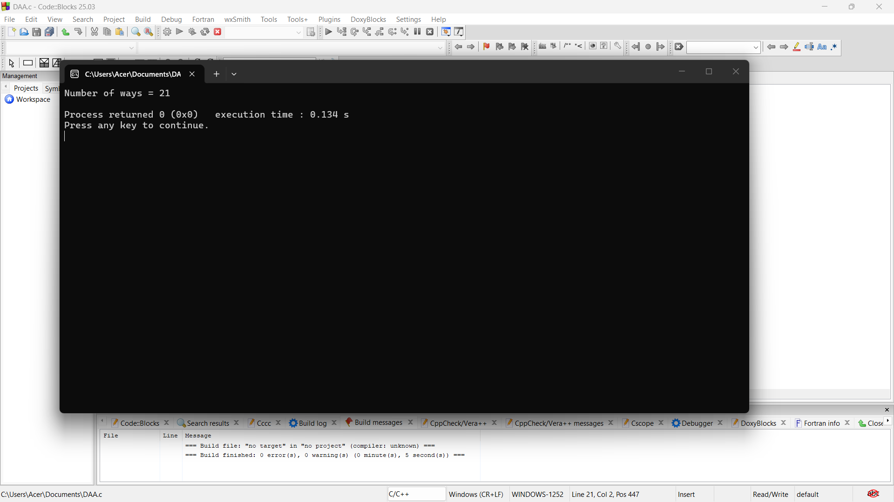

2. #include <stdio.h>

int main() {
int dice = 2, faces = 6, target = 7;
int dp[3][8] = {0};

dp[0][0] = 1;

for (int i = 1; i <= dice; i++) {
for (int j = 1; j <= target; j++) {
for (int k = 1; k <= faces; k++) {
if (j >= k)
dp[i][j] += dp[i - 1][j - k];
}
}
}

printf("Number of ways = %d", dp[dice][target]);

return 0;
}

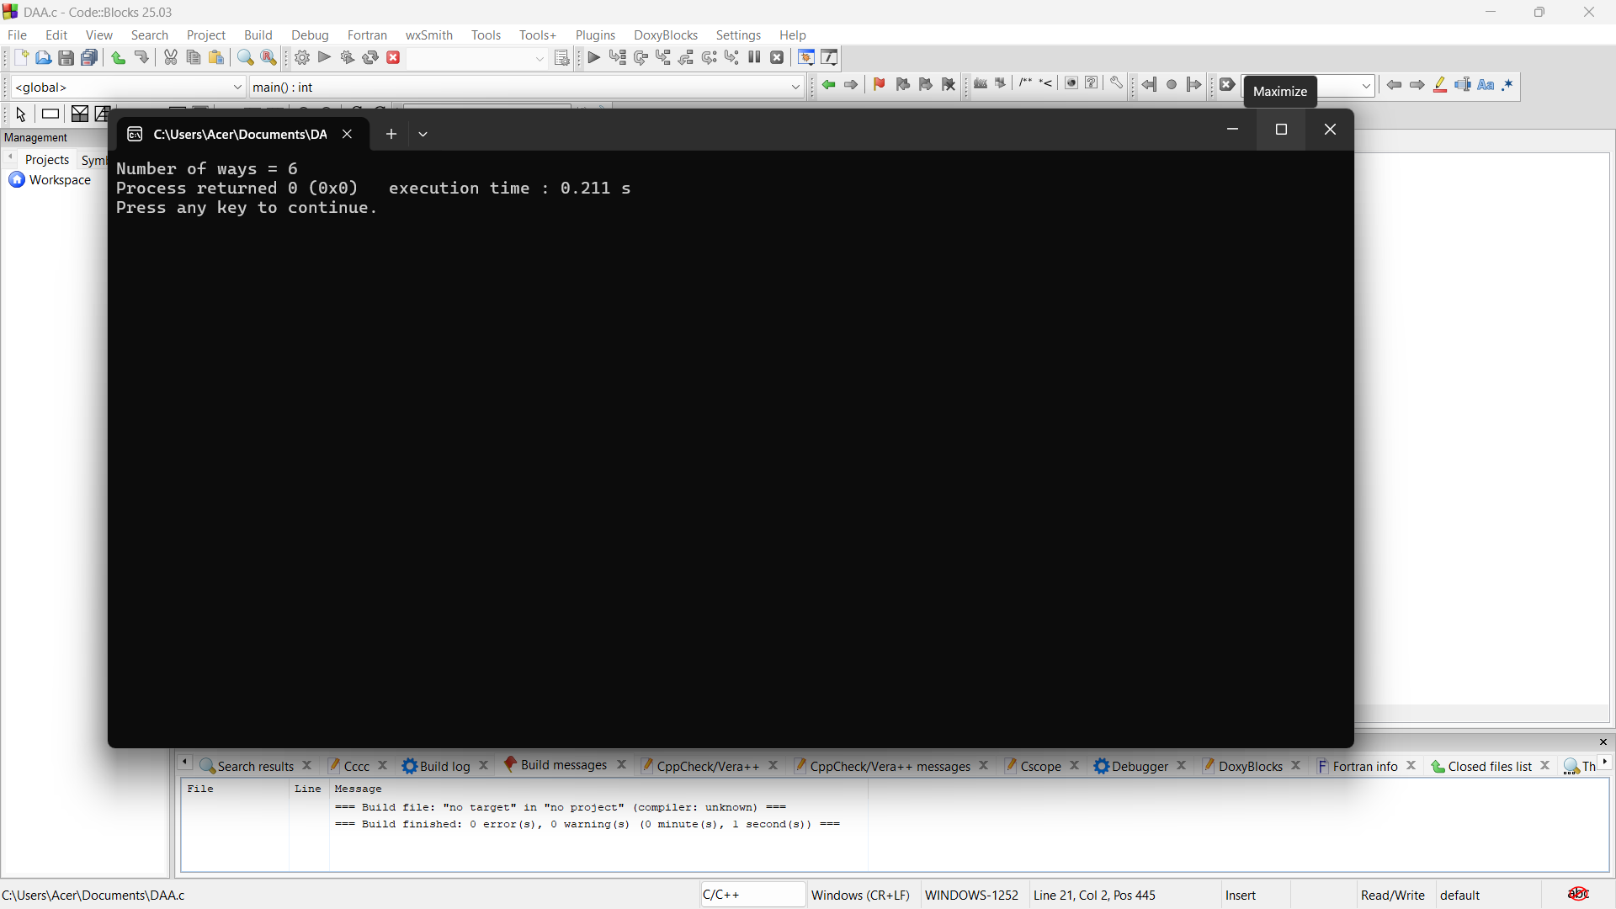

3. #include <stdio.h>

int main() {
int dice = 4, faces = 4, target = 10;
int dp[5][11] = {0};

dp[0][0] = 1;

for (int i = 1; i <= dice; i++) {
for (int j = 1; j <= target; j++) {
for (int k = 1; k <= faces; k++) {
if (j >= k)
dp[i][j] += dp[i - 1][j - k];
}
}
}

printf("Number of ways = %d", dp[dice][target]);

return 0;
}

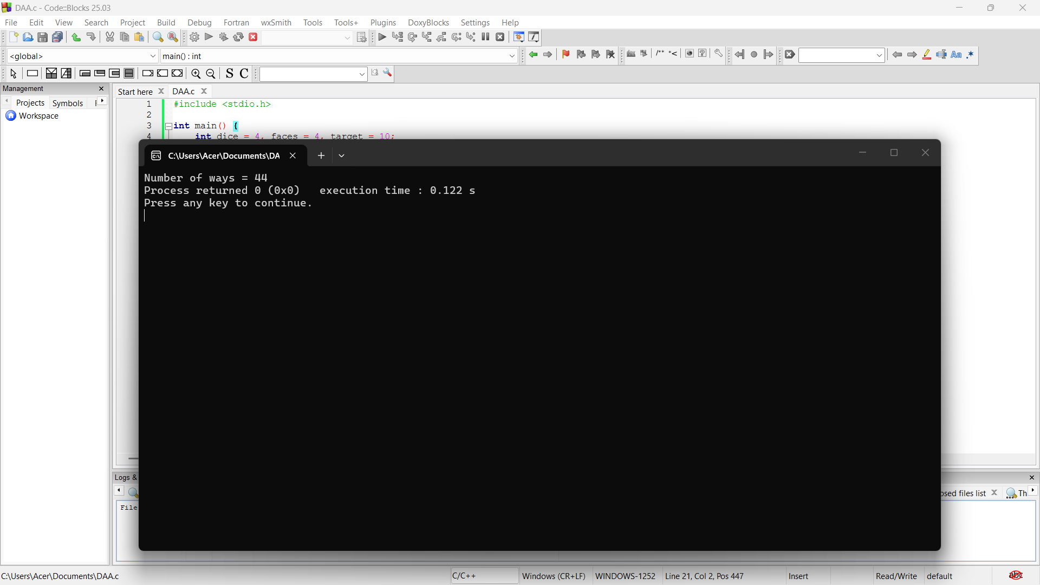

4. #include <stdio.h>

int main() {
int dice = 3, faces = 6, target = 12;
int dp[4][13] = {0};

dp[0][0] = 1;

for (int i = 1; i <= dice; i++) {
for (int j = 1; j <= target; j++) {
for (int k = 1; k <= faces; k++) {
if (j >= k)
dp[i][j] += dp[i - 1][j - k];
}
}
}

printf("Number of ways = %d", dp[dice][target]);

return 0;
}

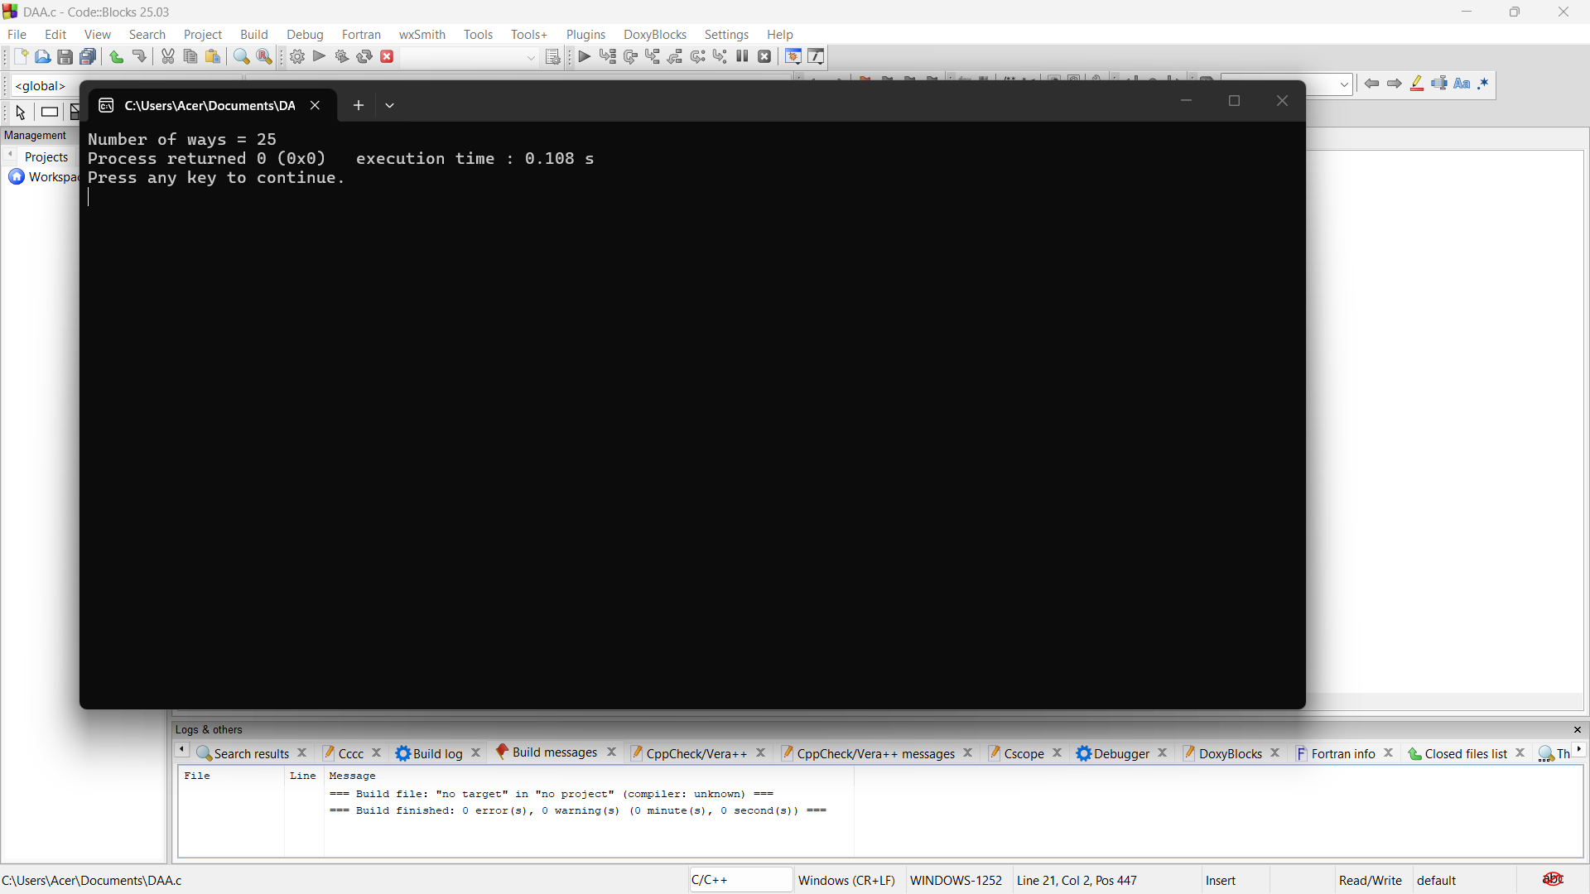

5. #include <stdio.h>

int main() {
int dice = 5, faces = 6, target = 15;
int dp[6][16] = {0};

dp[0][0] = 1;

for (int i = 1; i <= dice; i++) {
for (int j = 1; j <= target; j++) {
for (int k = 1; k <= faces; k++) {
if (j >= k)
dp[i][j] += dp[i - 1][j - k];
}
}
}

printf("Number of ways = %d", dp[dice][target]);

return 0;
}
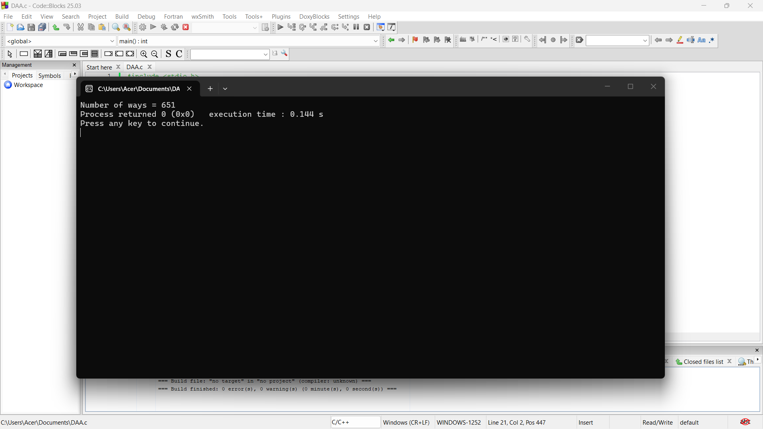

6. #include <stdio.h>

int main() {
int dice = 3, faces = 5, target = 9;
int dp[4][10] = {0};

dp[0][0] = 1;

for (int i = 1; i <= dice; i++) {
for (int j = 1; j <= target; j++) {
for (int k = 1; k <= faces; k++) {
if (j >= k)
dp[i][j] += dp[i - 1][j - k];
}
}
}

printf("Number of ways = %d", dp[dice][target]);

return 0;
}

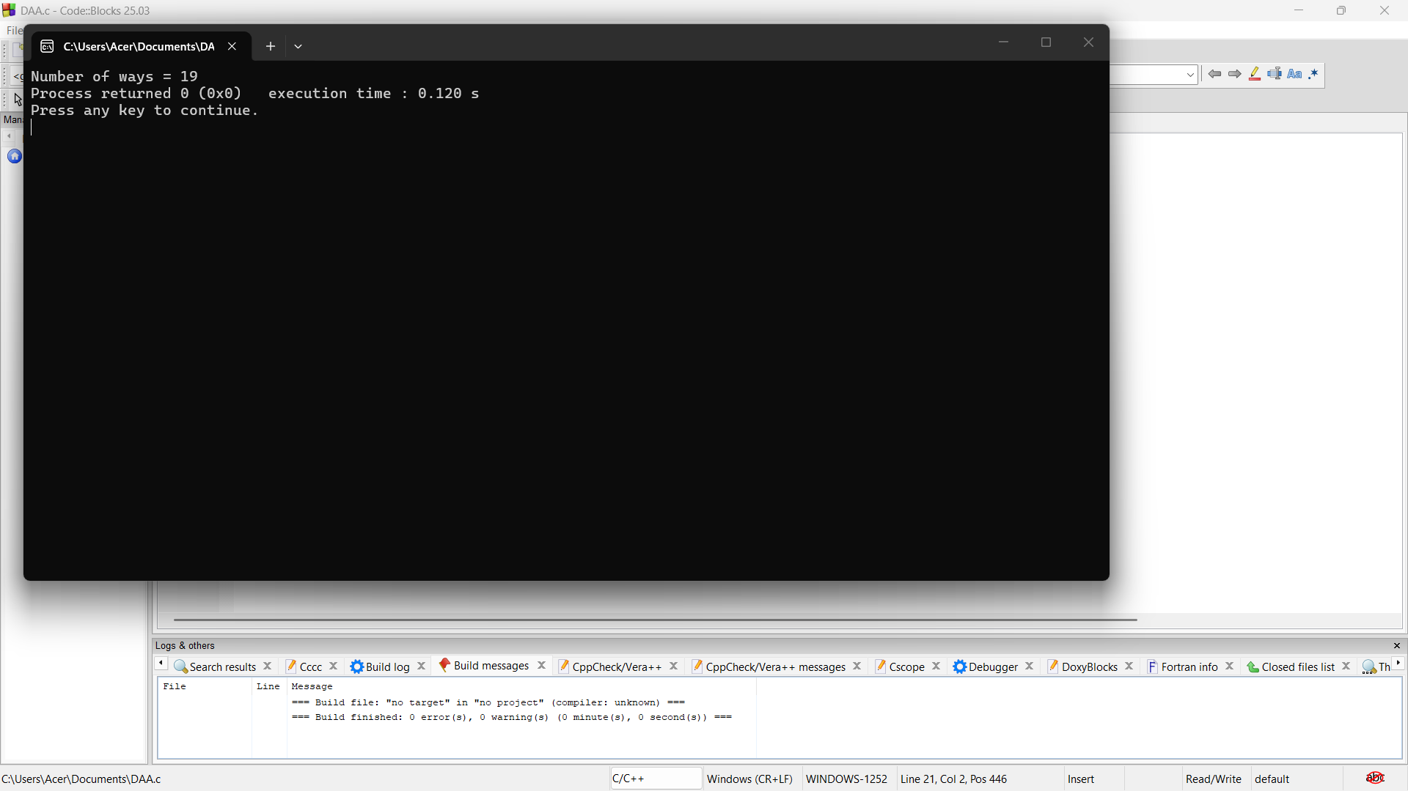

7. #include <stdio.h>

int main() {
int dice = 2, faces = 10, target = 11;
int dp[3][12] = {0};

dp[0][0] = 1;

for (int i = 1; i <= dice; i++) {
for (int j = 1; j <= target; j++) {
for (int k = 1; k <= faces; k++) {
if (j >= k)
dp[i][j] += dp[i - 1][j - k];
}
}
}

printf("Number of ways = %d", dp[dice][target]);

return 0;
}

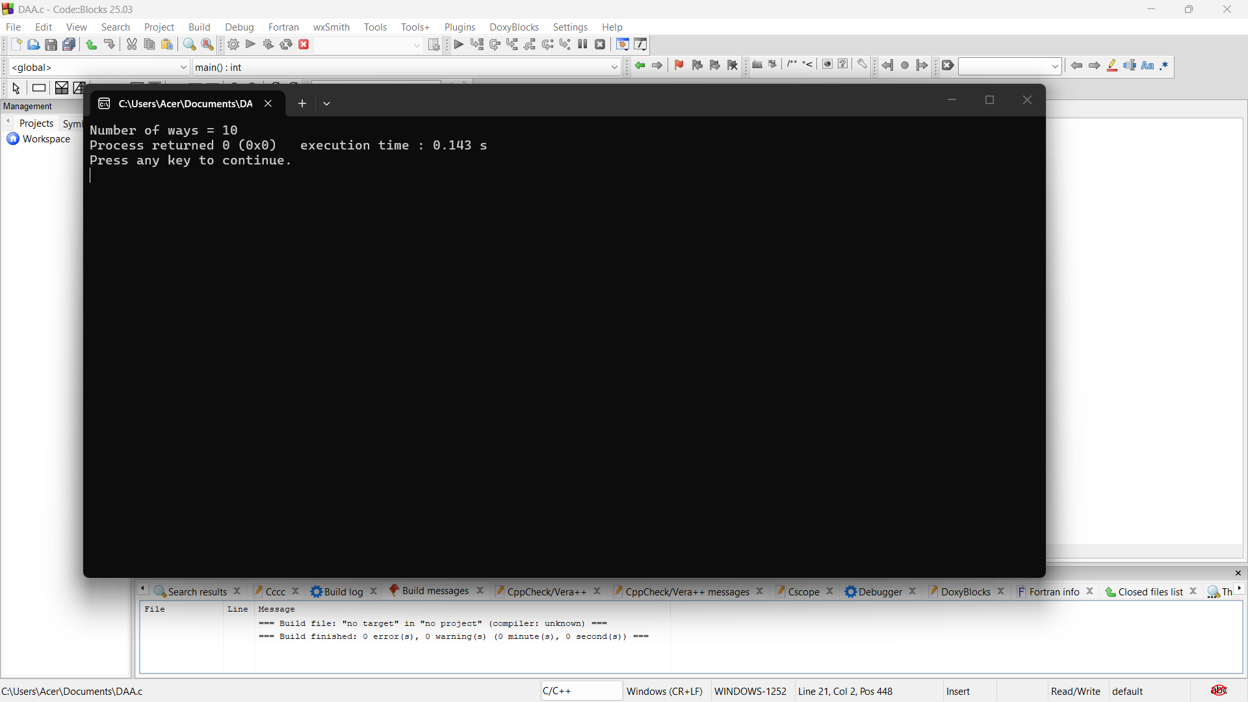

8. #include <stdio.h>

int main() {
int dice = 2, faces = 6, target = 7;
int dp[3][8] = {0};

dp[0][0] = 1;

for (int i = 1; i <= dice; i++) {
for (int j = 1; j <= target; j++) {
for (int k = 1; k <= faces; k++) {
if (j >= k)
dp[i][j] += dp[i - 1][j - k];
}
}
}

printf("Number of ways = %d", dp[dice][target]);

return 0;
}

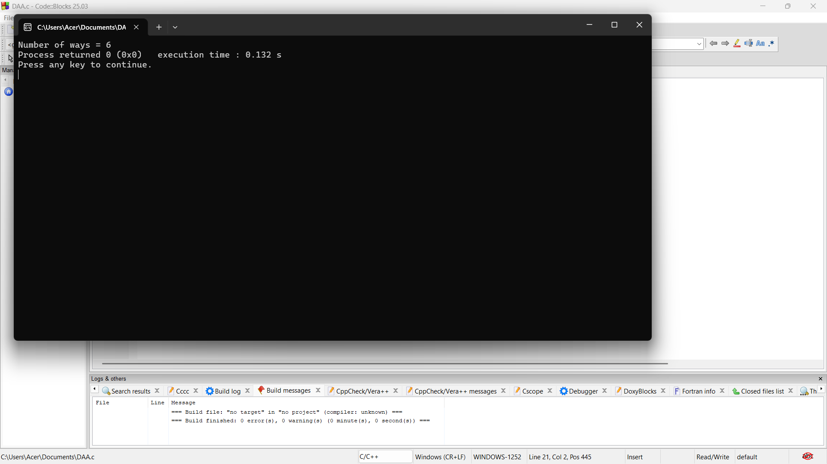

9.. #include <stdio.h>

int main() {
int dice = 3, faces = 6, target = 8;
int dp[4][9] = {0};

dp[0][0] = 1;

for (int i = 1; i <= dice; i++) {
for (int j = 1; j <= target; j++) {
for (int k = 1; k <= faces; k++) {
if (j >= k)
dp[i][j] += dp[i - 1][j - k];
}
}
}

printf("Number of ways = %d", dp[dice][target]);

return 0;
}

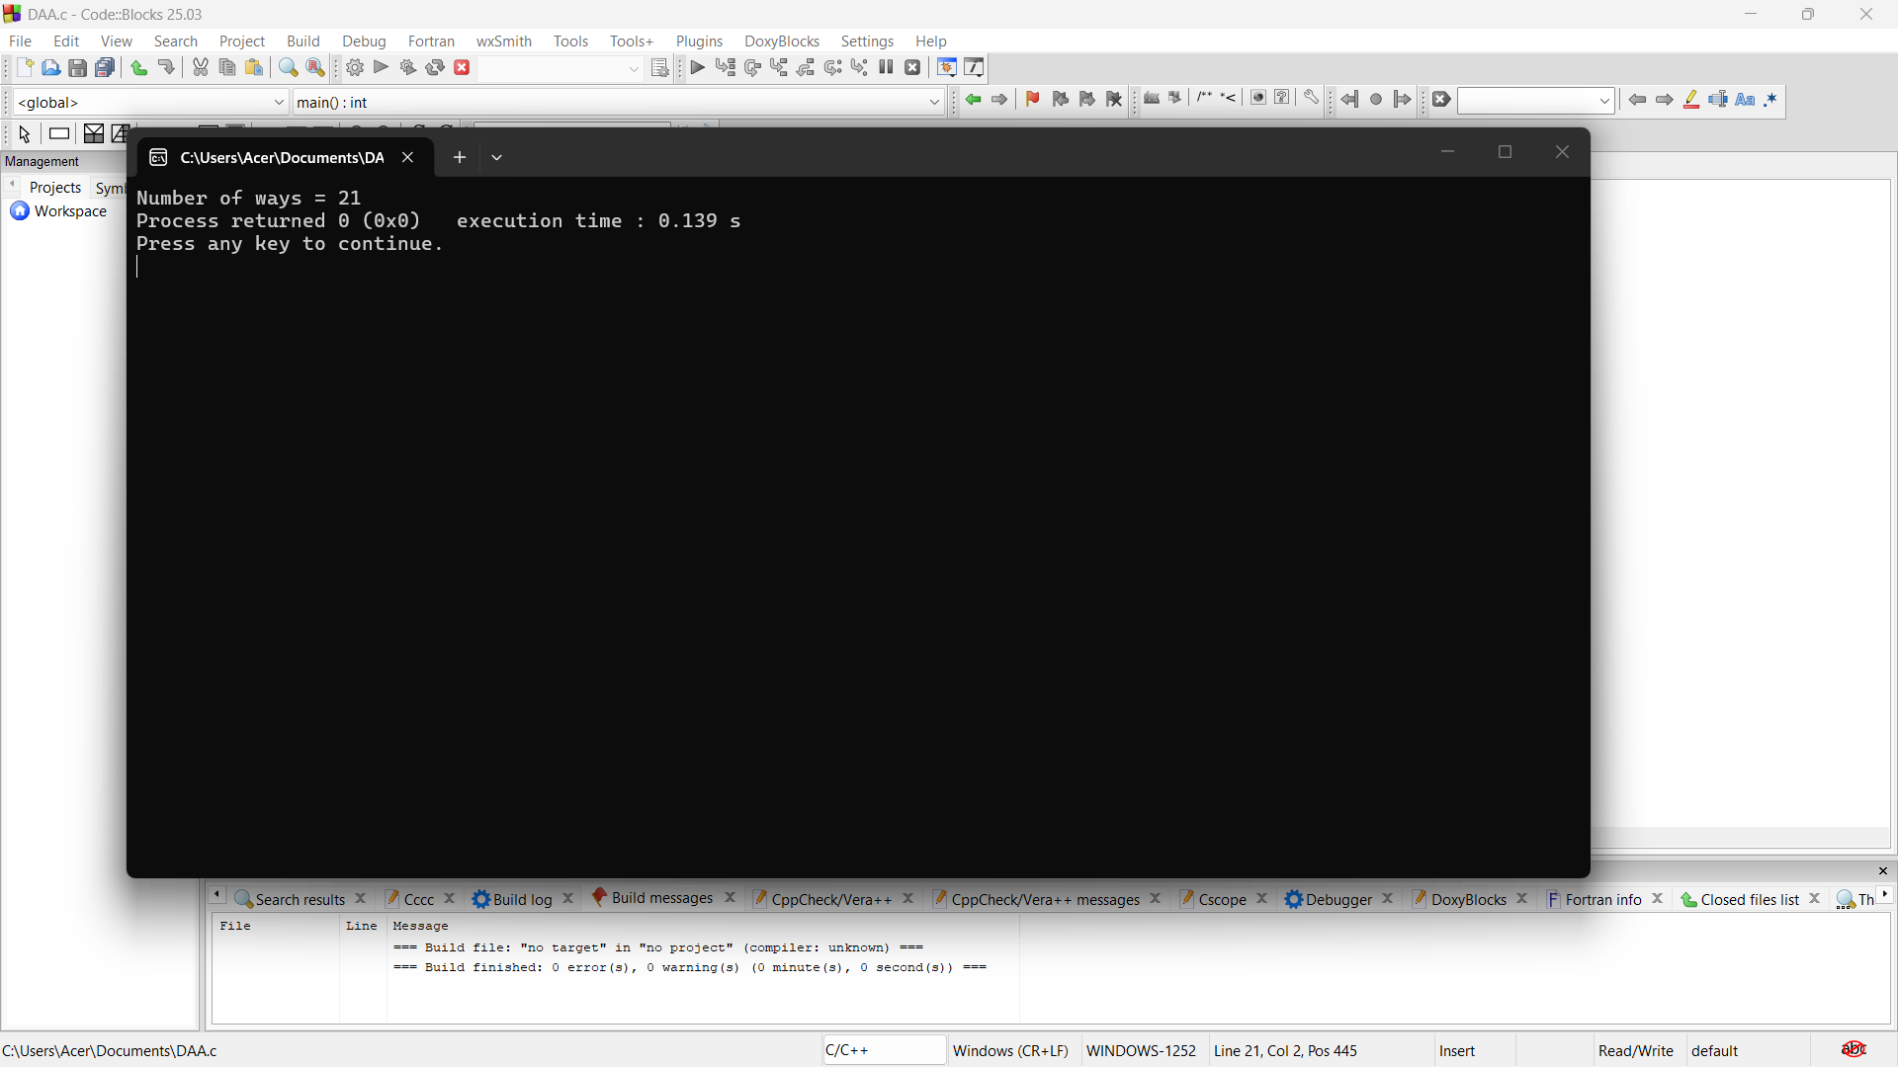

10. #include <stdio.h>

int main() {
int dice = 4, faces = 6, target = 10;
int dp[5][11] = {0};

dp[0][0] = 1;

for (int i = 1; i <= dice; i++) {
for (int j = 1; j <= target; j++) {
for (int k = 1; k <= faces; k++) {
if (j >= k)
dp[i][j] += dp[i - 1][j - k];
}
}
}

printf("Number of ways = %d", dp[dice][target]);

return 0;
}

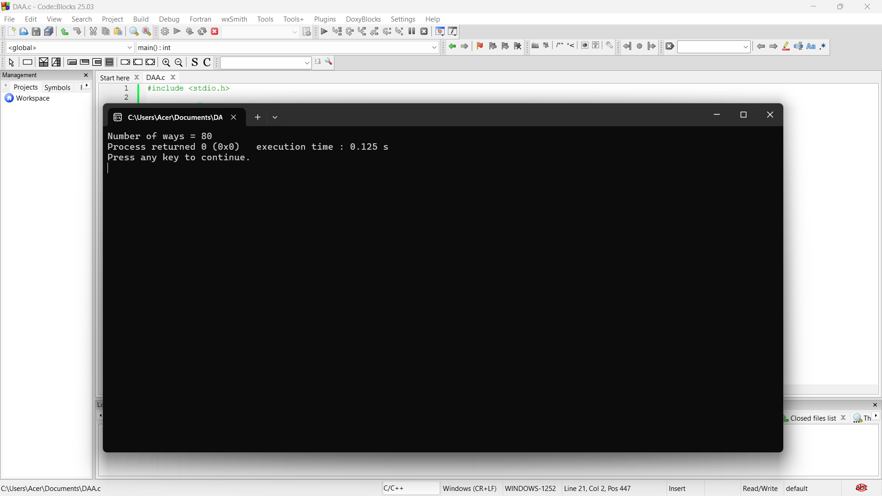

11. #include <stdio.h>

int main() {
int dice = 2, faces = 4, target = 5;
int dp[3][6] = {0};

dp[0][0] = 1;

for (int i = 1; i <= dice; i++) {
for (int j = 1; j <= target; j++) {
for (int k = 1; k <= faces; k++) {
if (j >= k)
dp[i][j] += dp[i - 1][j - k];
}
}
}

printf("Number of ways = %d", dp[dice][target]);

return 0;
}

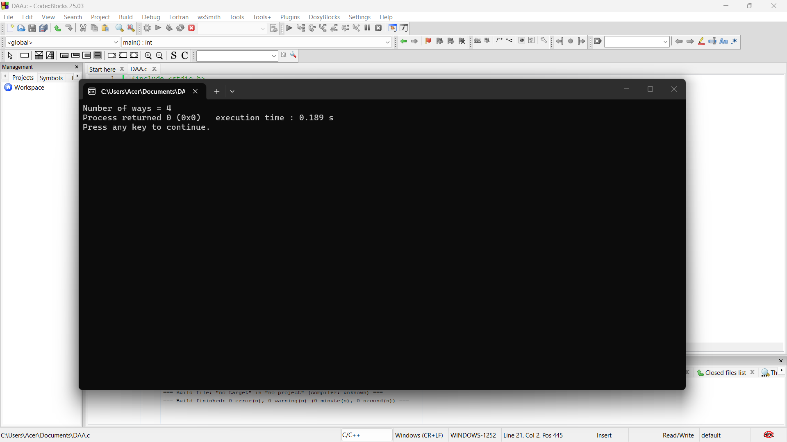

"Binomial Coefficient"
C Program (Dynamic Programming)
1.#include <stdio.h>

int main() {
int dice = 3, faces = 4, target = 7;
int dp[4][8] = {0};

dp[0][0] = 1;

for (int i = 1; i <= dice; i++) {
for (int j = 1; j <= target; j++) {
for (int k = 1; k <= faces; k++) {
if (j >= k)
dp[i][j] += dp[i - 1][j - k];
}
}
}

printf("Number of ways = %d", dp[dice][target]);

return 0;
}

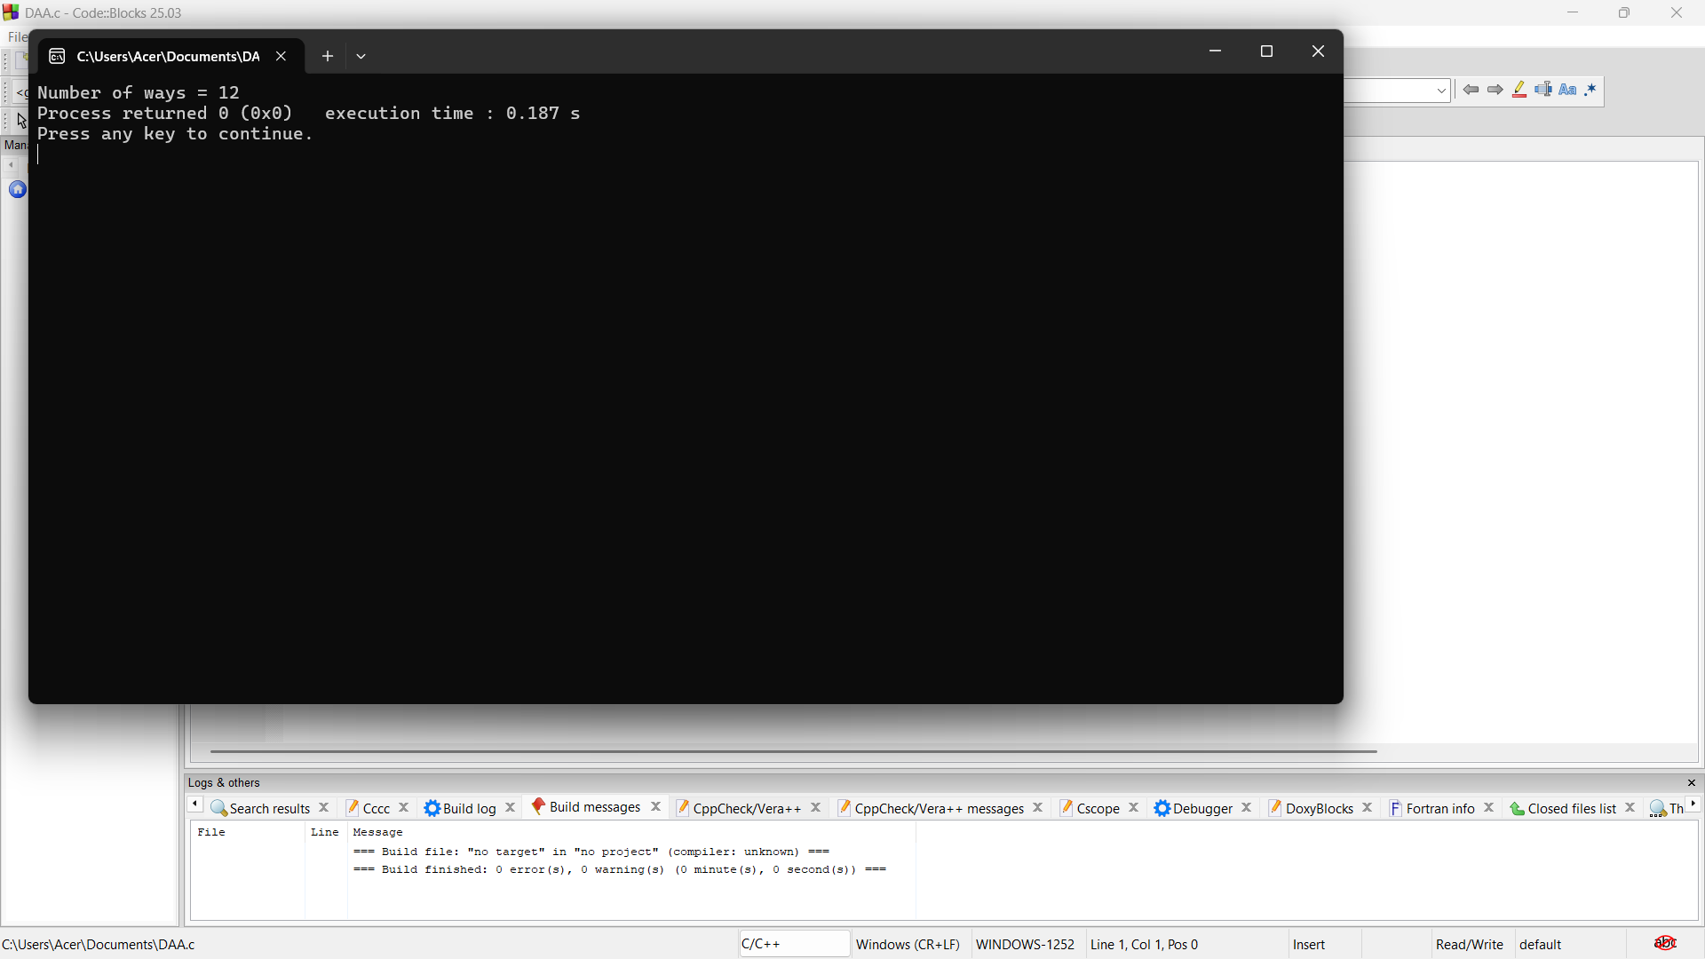

2. #include <stdio.h>

int main() {
int n = 5, r = 2;
int C[6][6] = {0};

for (int i = 0; i <= n; i++) {
for (int j = 0; j <= i && j <= r; j++) {
if (j == 0 || j == i)
C[i][j] = 1;
else
C[i][j] = C[i - 1][j - 1] + C[i - 1][j];
}
}

printf("C(%d,%d) = %d", n, r, C[n][r]);

return 0;
}

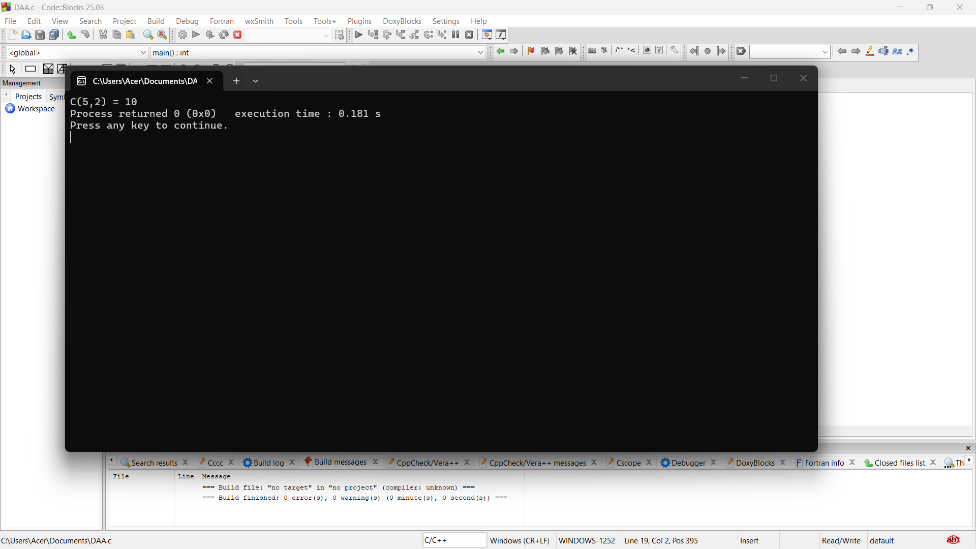

3. #include <stdio.h>

int main() {
int n = 8, r = 3;
int C[9][4] = {0};

for (int i = 0; i <= n; i++) {
for (int j = 0; j <= i && j <= r; j++) {
if (j == 0 || j == i)
C[i][j] = 1;
else
C[i][j] = C[i - 1][j - 1] + C[i - 1][j];
}
}

printf("C(%d,%d) = %d", n, r, C[n][r]);

return 0;
}

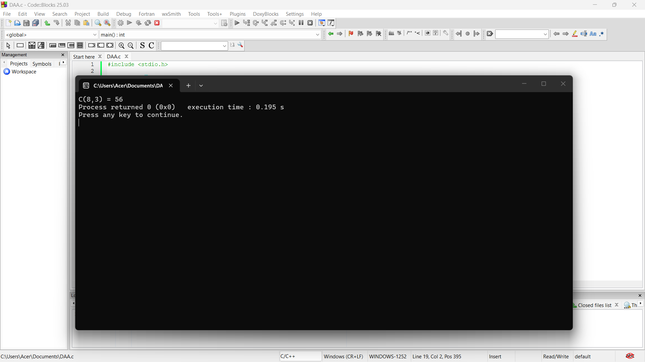

4. #include <stdio.h>

int main() {
int n = 10, r = 4;
int C[11][5] = {0};

for (int i = 0; i <= n; i++) {
for (int j = 0; j <= i && j <= r; j++) {
if (j == 0 || j == i)
C[i][j] = 1;
else
C[i][j] = C[i - 1][j - 1] + C[i - 1][j];
}
}

printf("C(%d,%d) = %d", n, r, C[n][r]);

return 0;
}

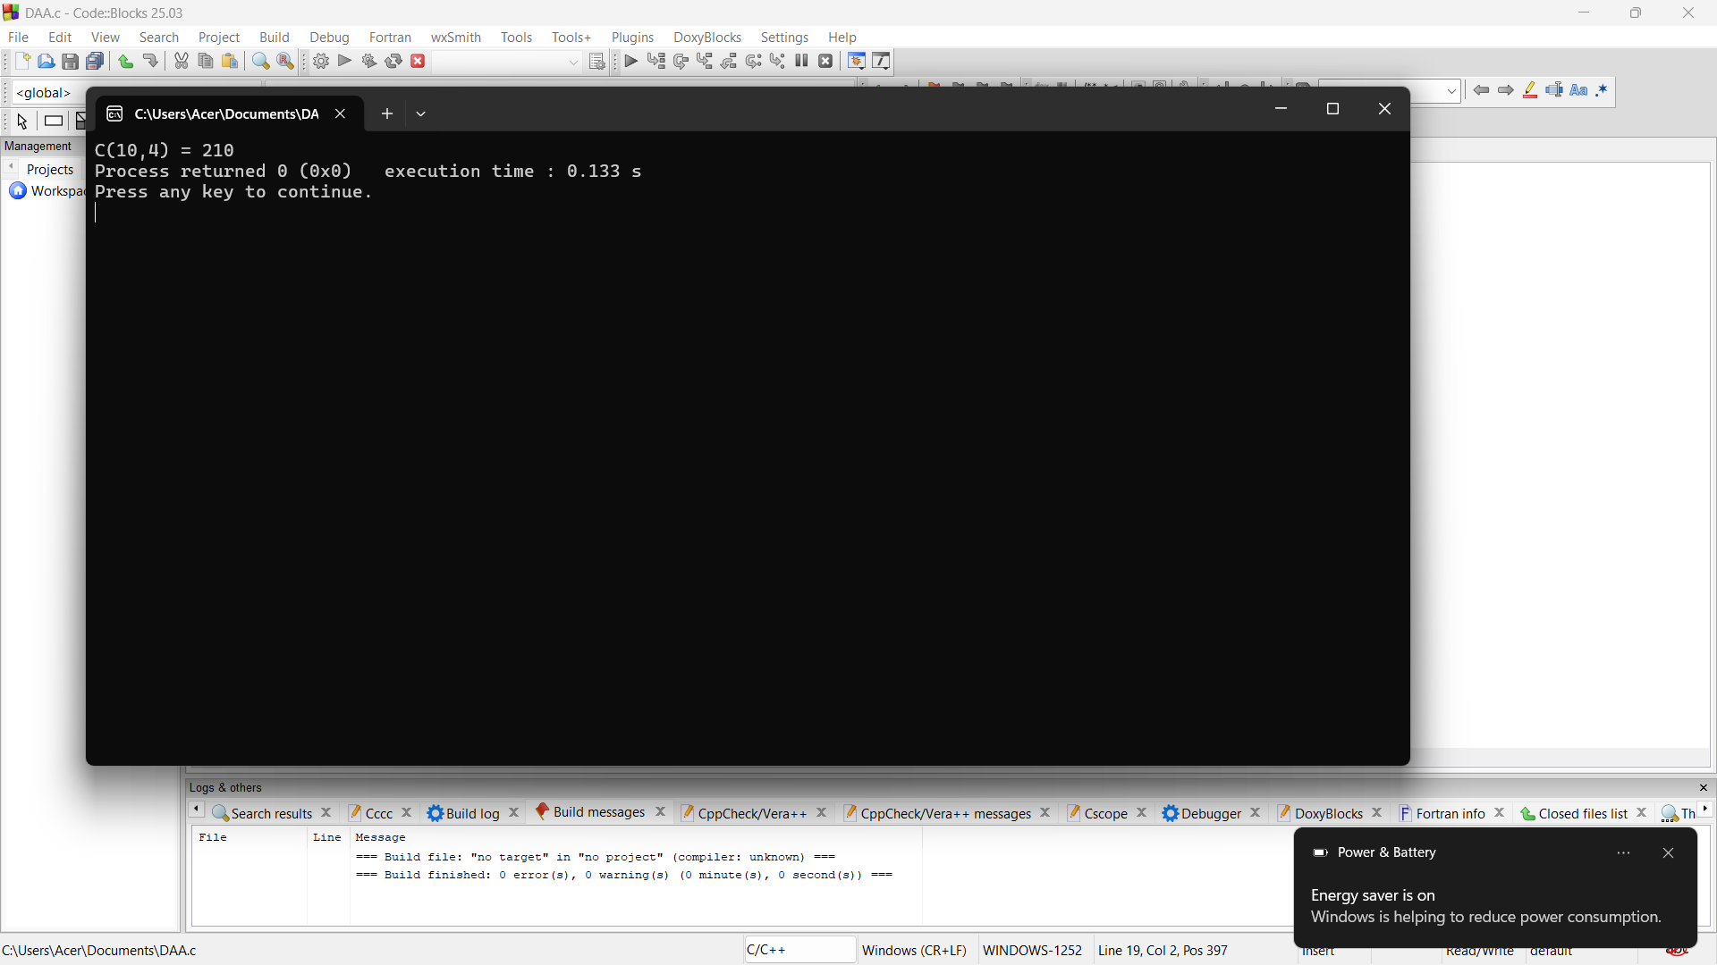

5. #include <stdio.h>

int main() {
int n = 12, r = 5;
int C[13][6] = {0};

for (int i = 0; i <= n; i++) {
for (int j = 0; j <= i && j <= r; j++) {
if (j == 0 || j == i)
C[i][j] = 1;
else
C[i][j] = C[i - 1][j - 1] + C[i - 1][j];
}
}

printf("Number of Committees = %d", C[n][r]);

return 0;
}

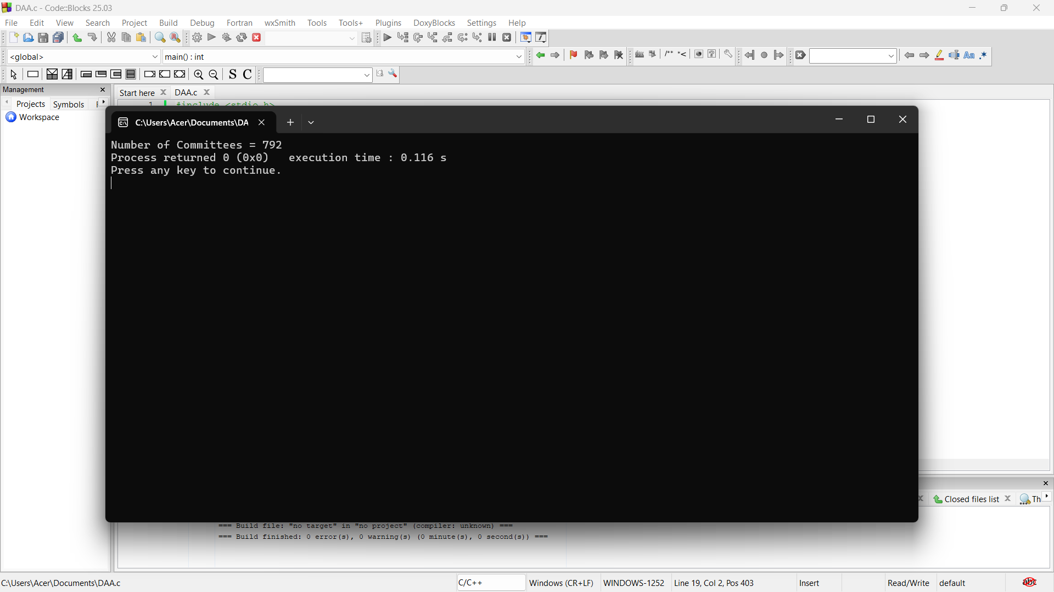

6. #include <stdio.h>

int main() {
int n = 15, r = 6;
int C[16][7] = {0};

for (int i = 0; i <= n; i++) {
for (int j = 0; j <= i && j <= r; j++) {
if (j == 0 || j == i)
C[i][j] = 1;
else
C[i][j] = C[i - 1][j - 1] + C[i - 1][j];
}
}

printf("C(%d,%d) = %d", n, r, C[n][r]);

return 0;
}

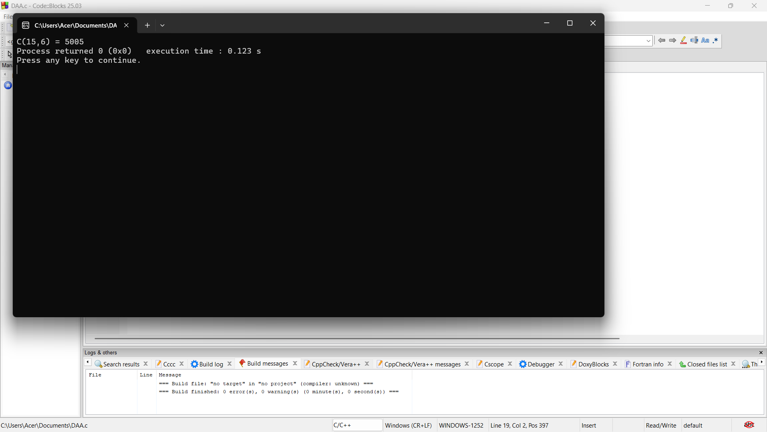

7. #include <stdio.h>

int main() {
int n = 10, r = 3;
int C[11][4] = {0};

for (int i = 0; i <= n; i++) {
for (int j = 0; j <= i && j <= r; j++) {
if (j == 0 || j == i)
C[i][j] = 1;
else
C[i][j] = C[i - 1][j - 1] + C[i - 1][j];
}
}

printf("Number of Teams = %d", C[n][r]);

return 0;
}

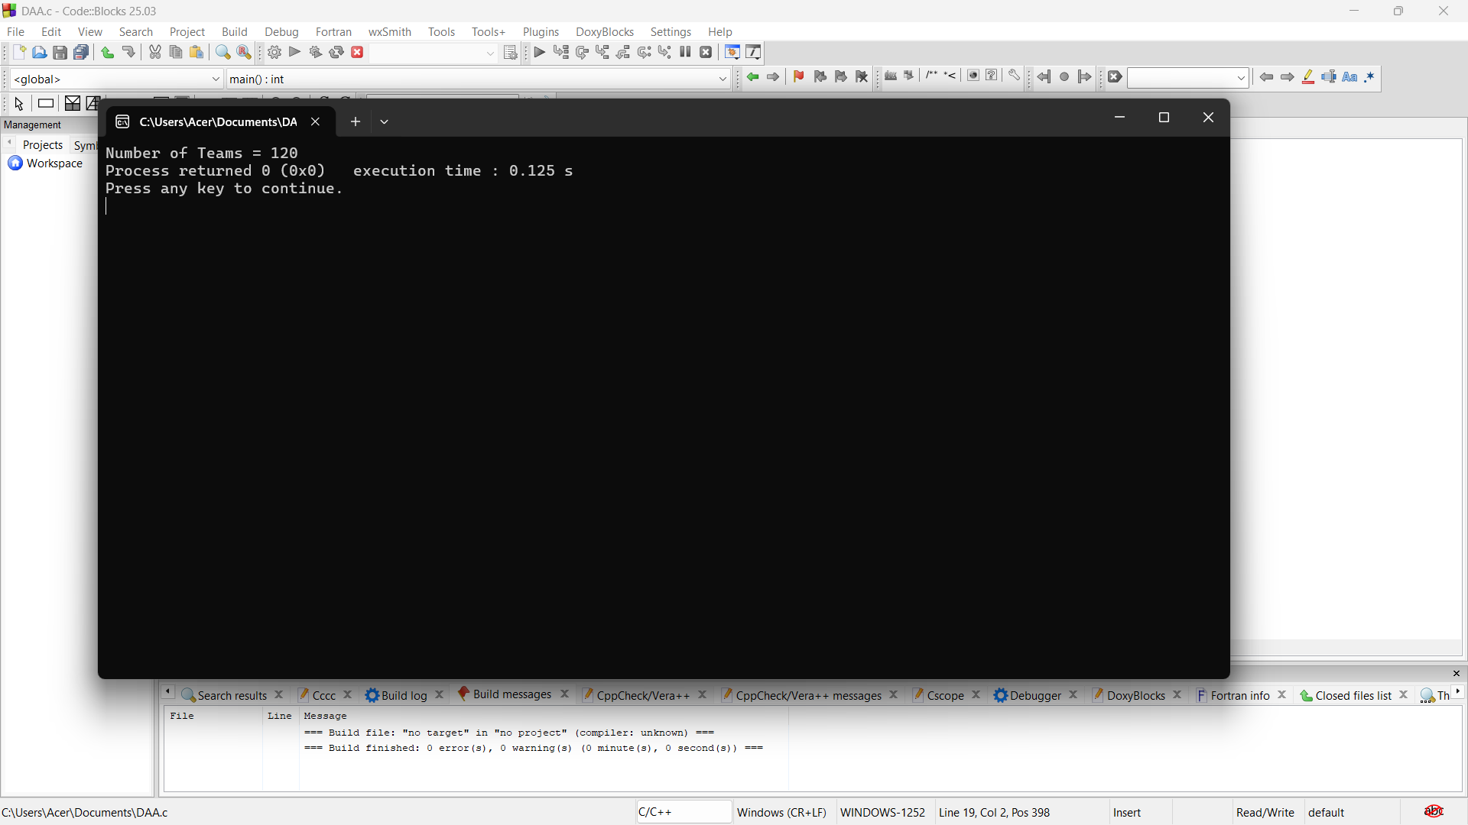

8. #include <stdio.h>

int main() {
int n = 12, r = 4;
int C[13][5] = {0};

for (int i = 0; i <= n; i++) {
for (int j = 0; j <= i && j <= r; j++) {
if (j == 0 || j == i)
C[i][j] = 1;
else
C[i][j] = C[i - 1][j - 1] + C[i - 1][j];
}
}

printf("Number of Committees = %d", C[n][r]);

return 0;
}

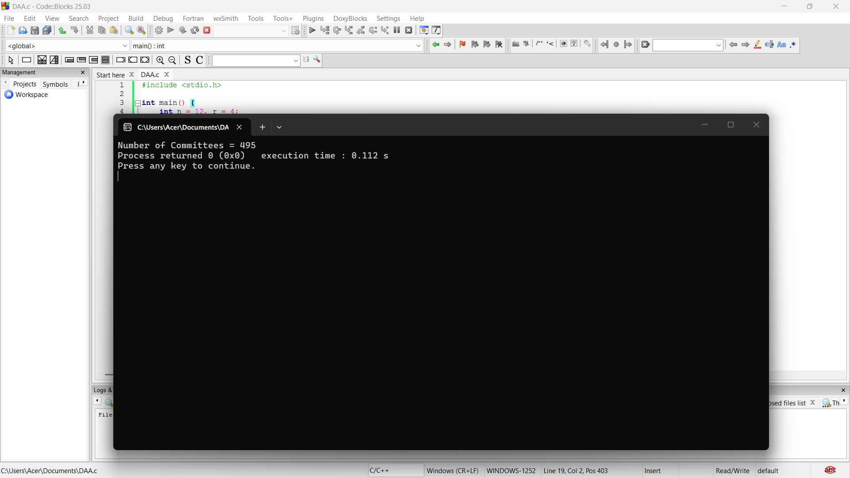

#include <stdio.h>

int main() {
int n = 15, r = 5;
int C[16][6] = {0};

for (int i = 0; i <= n; i++) {
for (int j = 0; j <= i && j <= r; j++) {
if (j == 0 || j == i)
C[i][j] = 1;
else
C[i][j] = C[i - 1][j - 1] + C[i - 1][j];
}
}

printf("Number of Selections = %d", C[n][r]);

return 0;
}

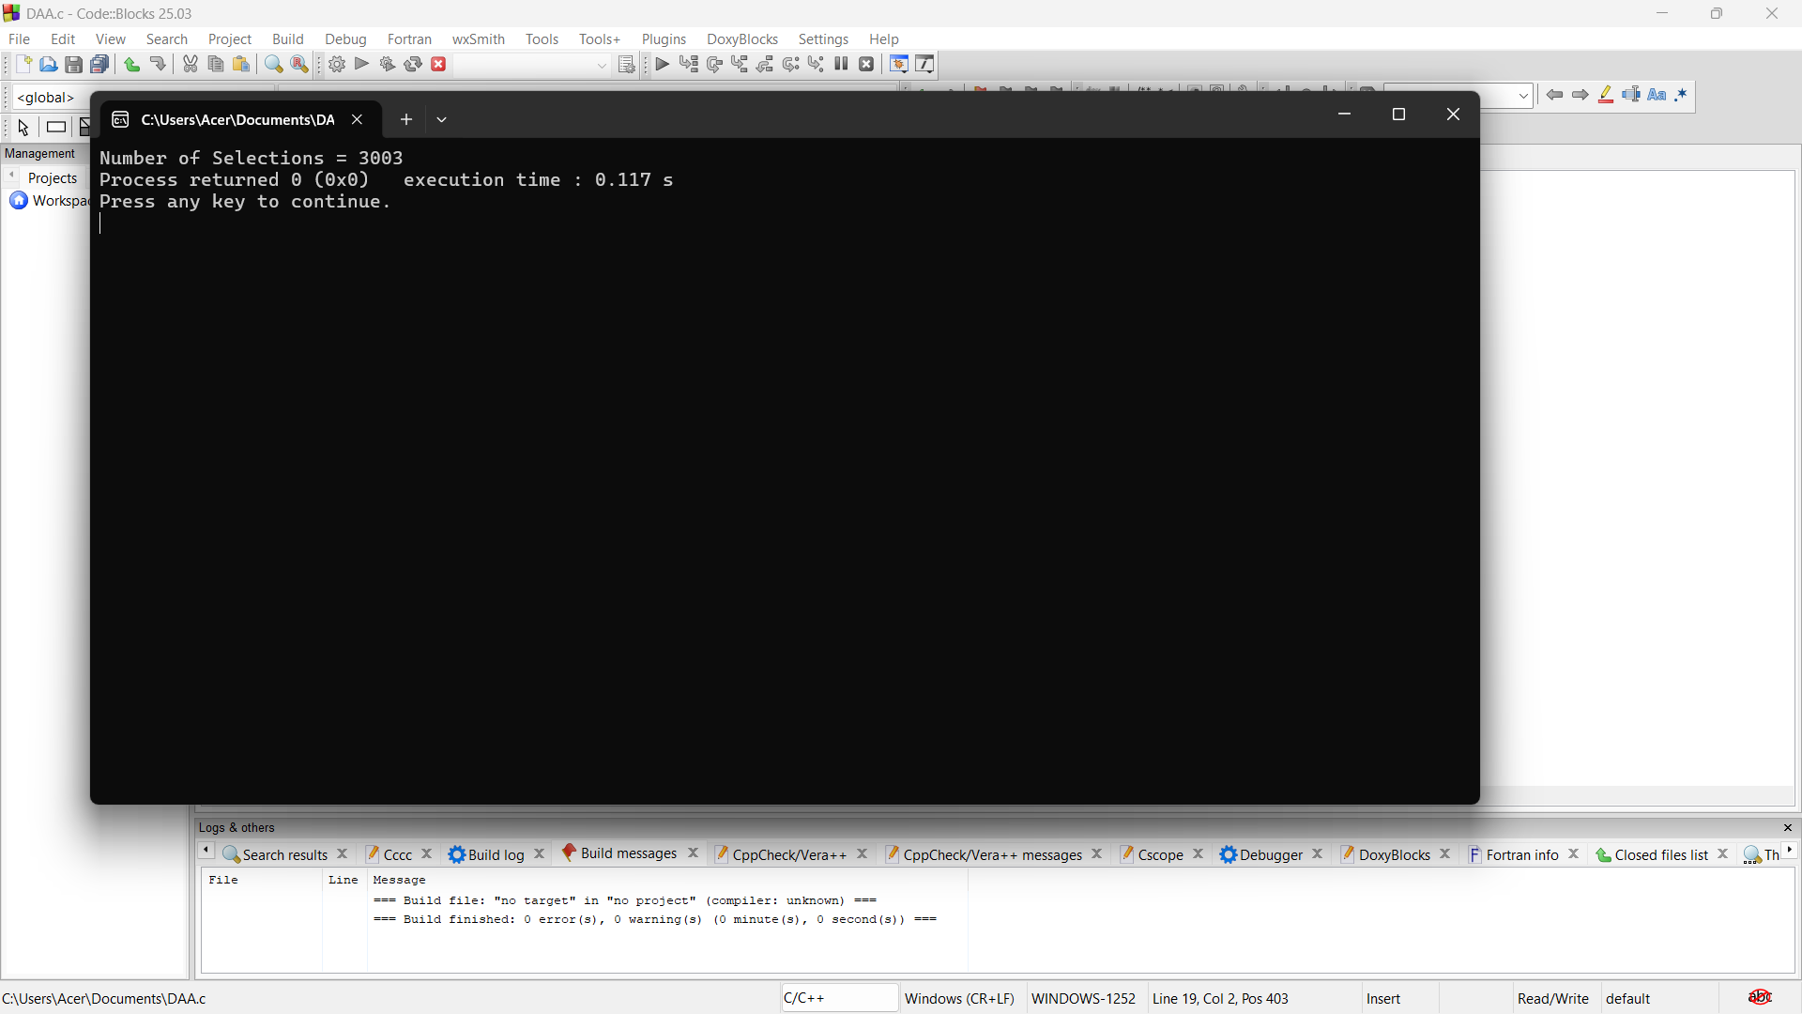

10. #include <stdio.h>

int main() {
int n = 20, r = 6;
int C[21][7] = {0};

for (int i = 0; i <= n; i++) {
for (int j = 0; j <= i && j <= r; j++) {
if (j == 0 || j == i)
C[i][j] = 1;
else
C[i][j] = C[i - 1][j - 1] + C[i - 1][j];
}
}

printf("Number of Groups = %d", C[n][r]);

return 0;
}

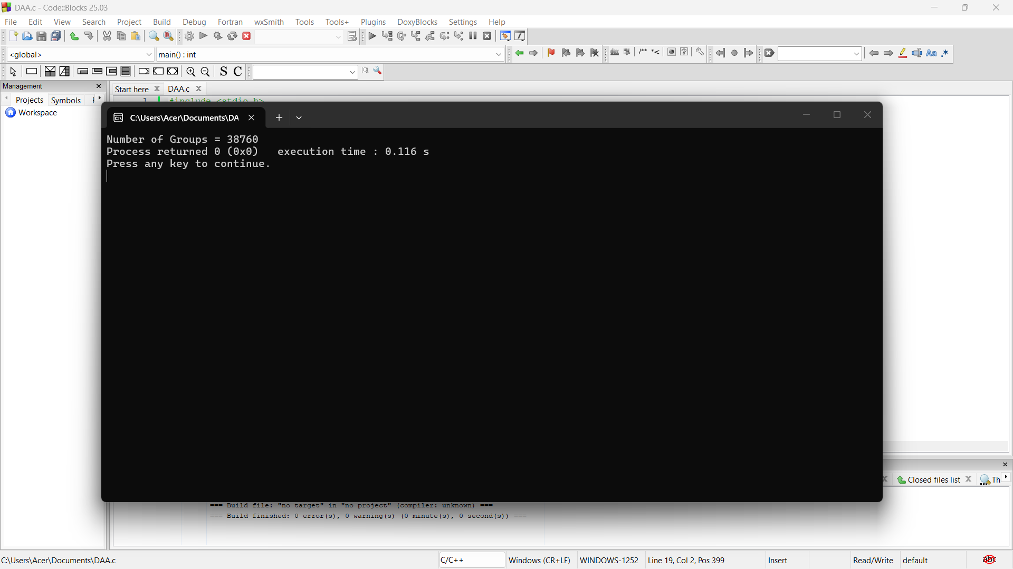

11. #include <stdio.h>

int main() {
int n = 8, r = 3;
int C[9][4] = {0};

for (int i = 0; i <= n; i++) {
for (int j = 0; j <= i && j <= r; j++) {
if (j == 0 || j == i)
C[i][j] = 1;
else
C[i][j] = C[i - 1][j - 1] + C[i - 1][j];
}
}

printf("Number of Combinations = %d", C[n][r]);

return 0;
}

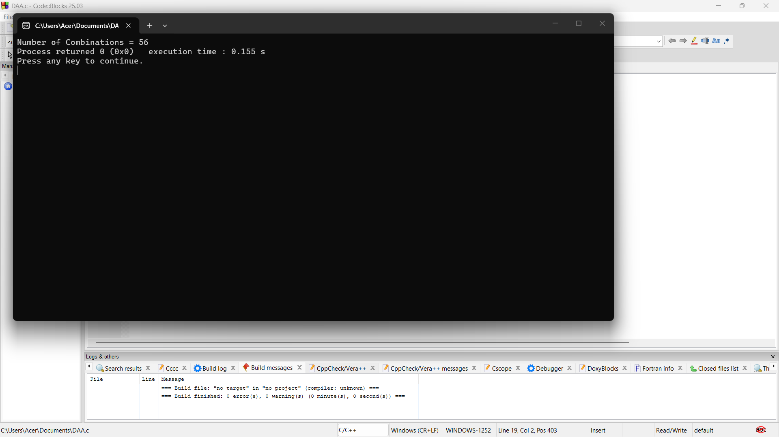

Assembly Line Scheduling

1. #include <stdio.h>

int main() {
int a1[] = {4, 5, 3, 2};
int a2[] = {2, 10, 1, 4};
int t1[] = {7, 4, 5};
int t2[] = {9, 2, 8};
int e1 = 10, e2 = 12;
int x1 = 18, x2 = 7;
int n = 4;

int f1[4], f2[4];

f1[0] = e1 + a1[0];
f2[0] = e2 + a2[0];

for (int i = 1; i < n; i++) {
if (f1[i - 1] + a1[i] < f2[i - 1] + t2[i - 1] + a1[i])
f1[i] = f1[i - 1] + a1[i];
else
f1[i] = f2[i - 1] + t2[i - 1] + a1[i];

if (f2[i - 1] + a2[i] < f1[i - 1] + t1[i - 1] + a2[i])
f2[i] = f2[i - 1] + a2[i];
else
f2[i] = f1[i - 1] + t1[i - 1] + a2[i];
}

int ans;
if (f1[n - 1] + x1 < f2[n - 1] + x2)
ans = f1[n - 1] + x1;
else
ans = f2[n - 1] + x2;

printf("Minimum Production Time = %d", ans);

return 0;
}

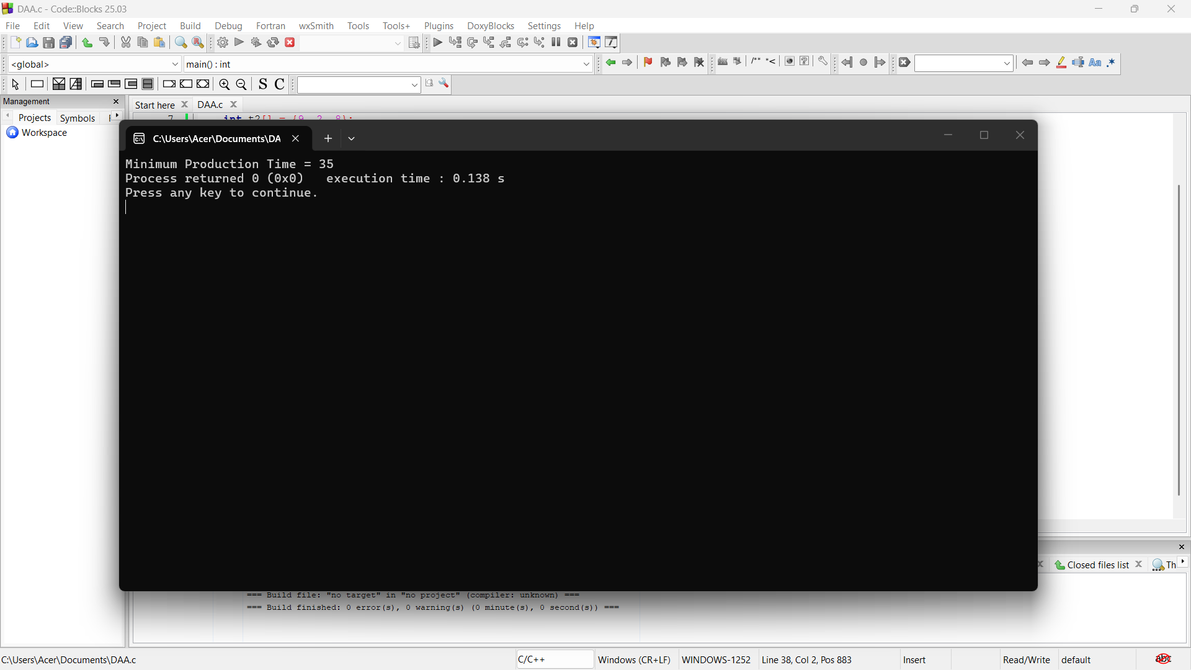

2. #include <stdio.h>

int main() {
int a1[] = {5, 6, 4};
int a2[] = {7, 3, 5};
int t1[] = {2, 1};
int t2[] = {3, 2};
int e1 = 8, e2 = 10;
int x1 = 12, x2 = 15;
int n = 3;

int f1[3], f2[3];

f1[0] = e1 + a1[0];
f2[0] = e2 + a2[0];

for (int i = 1; i < n; i++) {
if (f1[i-1] + a1[i] < f2[i-1] + t2[i-1] + a1[i])
f1[i] = f1[i-1] + a1[i];
else
f1[i] = f2[i-1] + t2[i-1] + a1[i];

if (f2[i-1] + a2[i] < f1[i-1] + t1[i-1] + a2[i])
f2[i] = f2[i-1] + a2[i];
else
f2[i] = f1[i-1] + t1[i-1] + a2[i];
}

int ans;
if (f1[n-1] + x1 < f2[n-1] + x2)
ans = f1[n-1] + x1;
else
ans = f2[n-1] + x2;

printf("Minimum Production Time = %d", ans);

return 0;
}

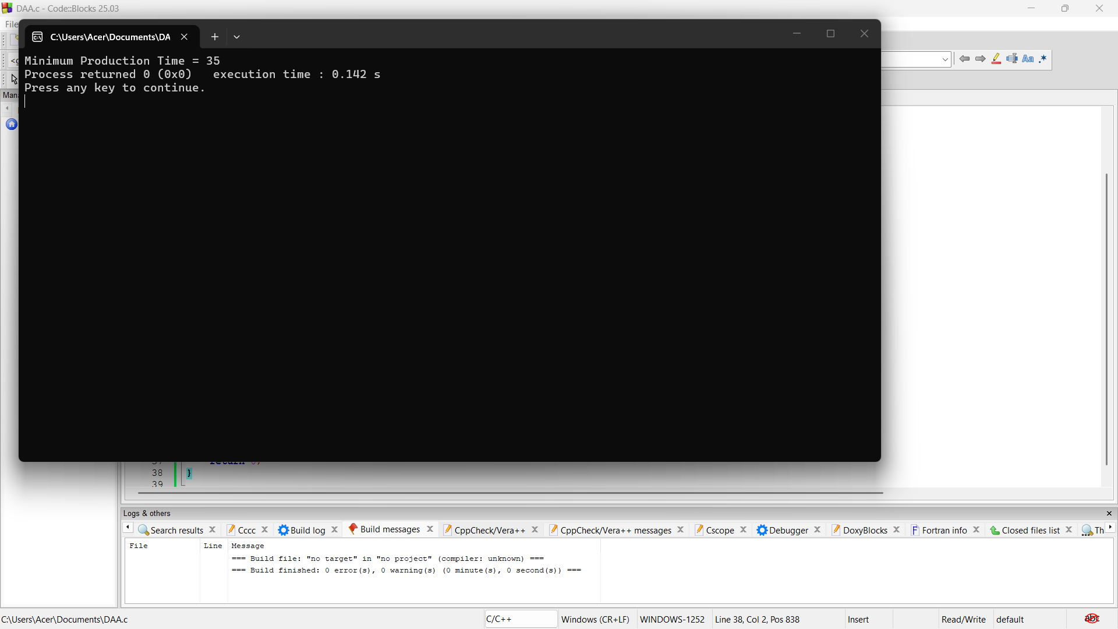

3. #include <stdio.h>

int main() {
int a1[] = {3, 4, 5};
int a2[] = {4, 3, 6};
int t1[] = {2, 1};
int t2[] = {1, 2};
int e1 = 5, e2 = 6;
int x1 = 4, x2 = 5;
int n = 3;

int f1[3], f2[3];

f1[0] = e1 + a1[0];
f2[0] = e2 + a2[0];

for (int i = 1; i < n; i++) {
if (f1[i - 1] + a1[i] < f2[i - 1] + t2[i - 1] + a1[i])
f1[i] = f1[i - 1] + a1[i];
else
f1[i] = f2[i - 1] + t2[i - 1] + a1[i];

if (f2[i - 1] + a2[i] < f1[i - 1] + t1[i - 1] + a2[i])
f2[i] = f2[i - 1] + a2[i];
else
f2[i] = f1[i - 1] + t1[i - 1] + a2[i];
}

int ans;
if (f1[n - 1] + x1 < f2[n - 1] + x2)
ans = f1[n - 1] + x1;
else
ans = f2[n - 1] + x2;

printf("Minimum Production Time = %d", ans);

return 0;
}

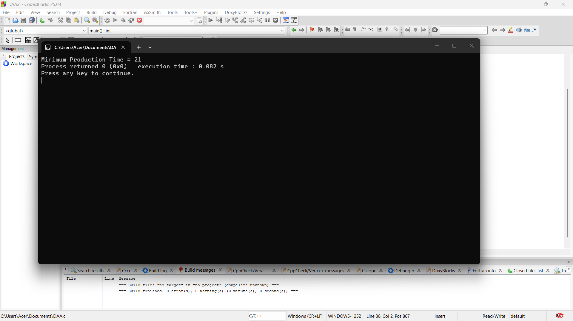

4. #include <stdio.h>

int main() {
int a1[] = {4, 3, 5, 2};
int a2[] = {5, 2, 4, 3};
int t1[] = {1, 2, 1};
int t2[] = {2, 1, 2};
int e1 = 7, e2 = 9;
int x1 = 8, x2 = 6;
int n = 4;

int f1[4], f2[4];

f1[0] = e1 + a1[0];
f2[0] = e2 + a2[0];

for (int i = 1; i < n; i++) {
if (f1[i - 1] + a1[i] < f2[i - 1] + t2[i - 1] + a1[i])
f1[i] = f1[i - 1] + a1[i];
else
f1[i] = f2[i - 1] + t2[i - 1] + a1[i];

if (f2[i - 1] + a2[i] < f1[i - 1] + t1[i - 1] + a2[i])
f2[i] = f2[i - 1] + a2[i];
else
f2[i] = f1[i - 1] + t1[i - 1] + a2[i];
}

int ans;
if (f1[n - 1] + x1 < f2[n - 1] + x2)
ans = f1[n - 1] + x1;
else
ans = f2[n - 1] + x2;

printf("Minimum Production Time = %d", ans);

return 0;
}

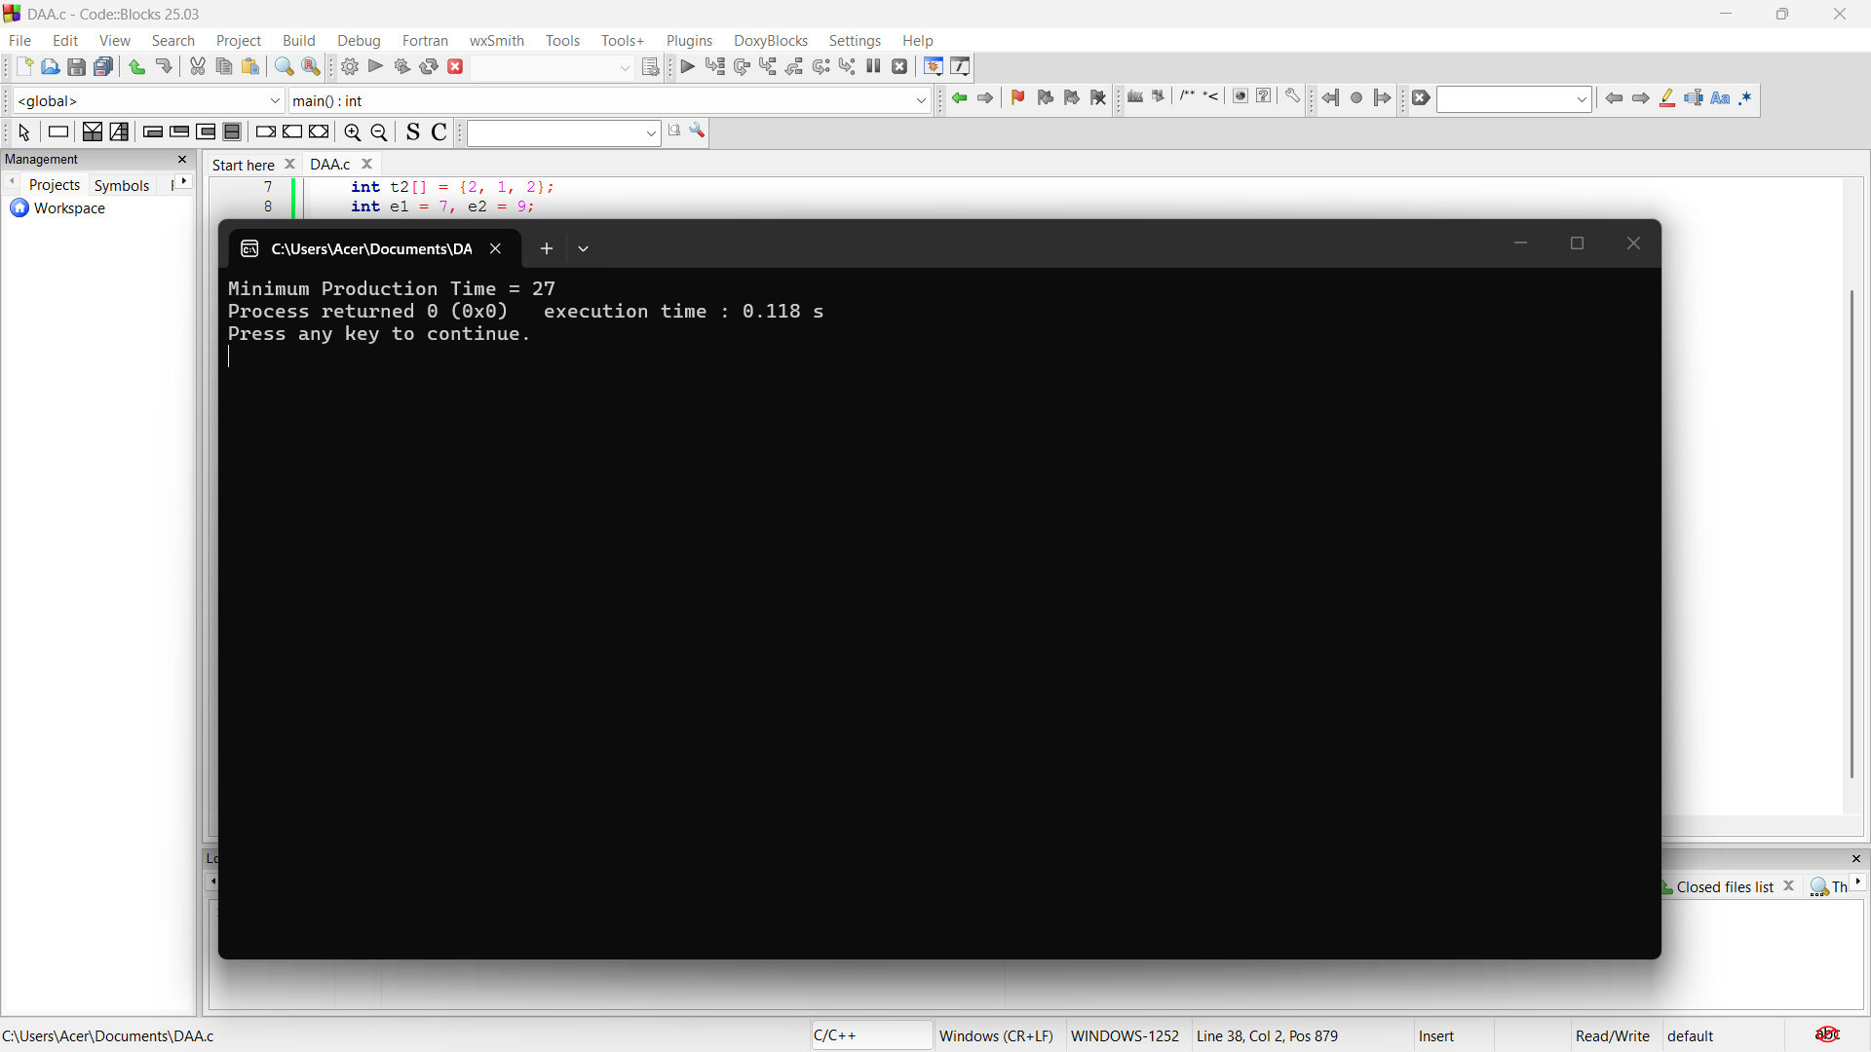

5. #include <stdio.h>

int main() {
int a1[] = {2, 4, 3};
int a2[] = {3, 2, 5};
int t1[] = {1, 2};
int t2[] = {2, 1};
int e1 = 6, e2 = 7;
int x1 = 5, x2 = 4;
int n = 3;

int f1[3], f2[3];

f1[0] = e1 + a1[0];
f2[0] = e2 + a2[0];

for (int i = 1; i < n; i++) {
if (f1[i-1] + a1[i] < f2[i-1] + t2[i-1] + a1[i])
f1[i] = f1[i-1] + a1[i];
else
f1[i] = f2[i-1] + t2[i-1] + a1[i];

if (f2[i-1] + a2[i] < f1[i-1] + t1[i-1] + a2[i])
f2[i] = f2[i-1] + a2[i];
else
f2[i] = f1[i-1] + t1[i-1] + a2[i];
}

int ans;
if (f1[n-1] + x1 < f2[n-1] + x2)
ans = f1[n-1] + x1;
else
ans = f2[n-1] + x2;

printf("Minimum Production Time = %d", ans);

return 0;
}

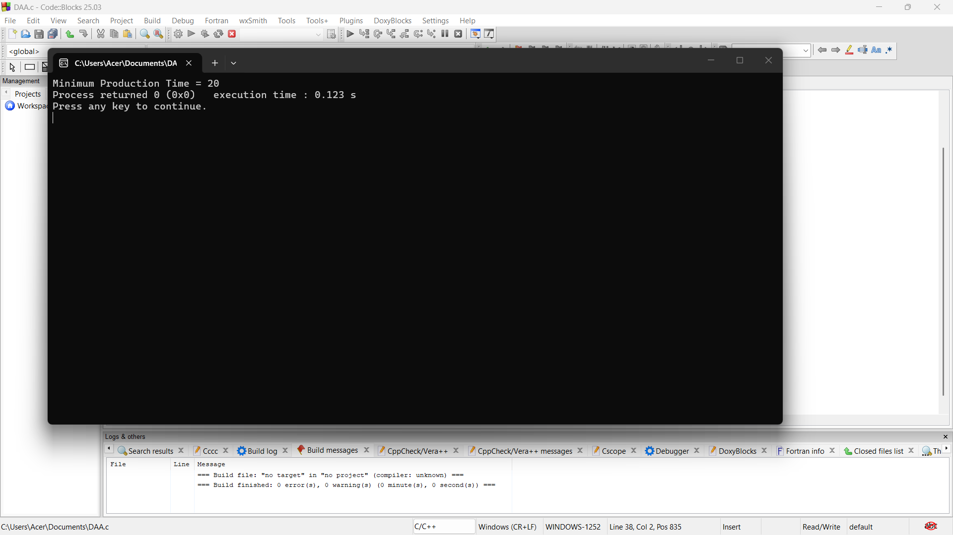

6. #include <stdio.h>

int main() {
int a1[] = {4, 5, 3, 2};
int a2[] = {2, 10, 1, 4};
int t1[] = {7, 4, 5};
int t2[] = {9, 2, 8};
int e1 = 10, e2 = 12;
int x1 = 18, x2 = 7;
int n = 4;

int f1[4], f2[4];

f1[0] = e1 + a1[0];
f2[0] = e2 + a2[0];

for (int i = 1; i < n; i++) {
if (f1[i - 1] + a1[i] < f2[i - 1] + t2[i - 1] + a1[i])
f1[i] = f1[i - 1] + a1[i];
else
f1[i] = f2[i - 1] + t2[i - 1] + a1[i];

if (f2[i - 1] + a2[i] < f1[i - 1] + t1[i - 1] + a2[i])
f2[i] = f2[i - 1] + a2[i];
else
f2[i] = f1[i - 1] + t1[i - 1] + a2[i];
}

int ans;
if (f1[n - 1] + x1 < f2[n - 1] + x2)
ans = f1[n - 1] + x1;
else
ans = f2[n - 1] + x2;

printf("Minimum Production Time = %d", ans);

return 0;
}

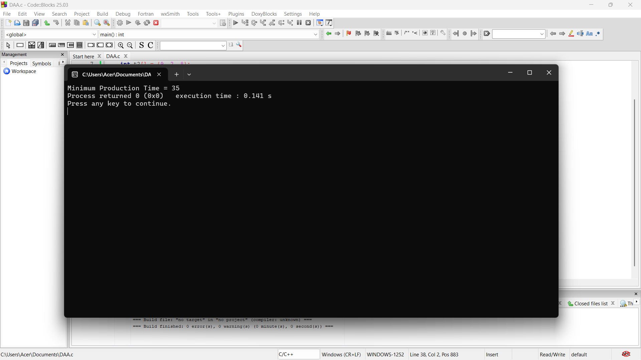

7. #include <stdio.h>

int main() {
int a1[] = {5, 6, 4};
int a2[] = {7, 3, 5};
int t1[] = {2, 1};
int t2[] = {3, 2};
int e1 = 8, e2 = 10;
int x1 = 12, x2 = 15;
int n = 3;

int f1[3], f2[3];

f1[0] = e1 + a1[0];
f2[0] = e2 + a2[0];

for (int i = 1; i < n; i++) {
if (f1[i - 1] + a1[i] < f2[i - 1] + t2[i - 1] + a1[i])
f1[i] = f1[i - 1] + a1[i];
else
f1[i] = f2[i - 1] + t2[i - 1] + a1[i];

if (f2[i - 1] + a2[i] < f1[i - 1] + t1[i - 1] + a2[i])
f2[i] = f2[i - 1] + a2[i];
else
f2[i] = f1[i - 1] + t1[i - 1] + a2[i];
}

int ans;
if (f1[n - 1] + x1 < f2[n - 1] + x2)
ans = f1[n - 1] + x1;
else
ans = f2[n - 1] + x2;

printf("Minimum Production Time = %d", ans);

return 0;
}

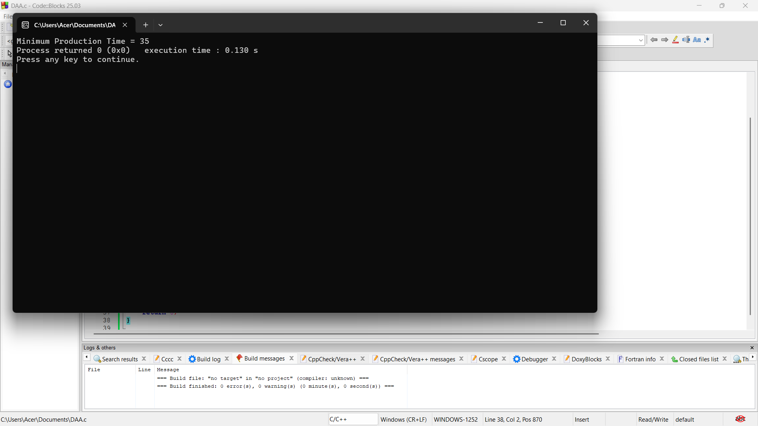

8. #include <stdio.h>

int main() {
int a1[] = {3, 4, 5};
int a2[] = {4, 3, 6};
int t1[] = {2, 1};
int t2[] = {1, 2};
int e1 = 5, e2 = 6;
int x1 = 4, x2 = 5;
int n = 3;

int f1[3], f2[3];

f1[0] = e1 + a1[0];
f2[0] = e2 + a2[0];

for (int i = 1; i < n; i++) {
if (f1[i - 1] + a1[i] < f2[i - 1] + t2[i - 1] + a1[i])
f1[i] = f1[i - 1] + a1[i];
else
f1[i] = f2[i - 1] + t2[i - 1] + a1[i];

if (f2[i - 1] + a2[i] < f1[i - 1] + t1[i - 1] + a2[i])
f2[i] = f2[i - 1] + a2[i];
else
f2[i] = f1[i - 1] + t1[i - 1] + a2[i];
}

int ans;
if (f1[n - 1] + x1 < f2[n - 1] + x2)
ans = f1[n - 1] + x1;
else
ans = f2[n - 1] + x2;

printf("Minimum Production Time = %d", ans);

return 0;
}

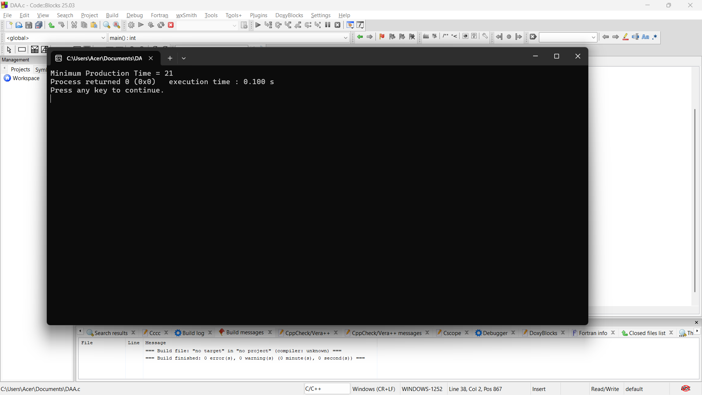

9. #include <stdio.h>

int main() {
int a1[] = {4, 3, 5, 2};
int a2[] = {5, 2, 4, 3};
int t1[] = {1, 2, 1};
int t2[] = {2, 1, 2};
int e1 = 7, e2 = 9;
int x1 = 8, x2 = 6;
int n = 4;

int f1[4], f2[4];

f1[0] = e1 + a1[0];
f2[0] = e2 + a2[0];

for (int i = 1; i < n; i++) {
if (f1[i - 1] + a1[i] < f2[i - 1] + t2[i - 1] + a1[i])
f1[i] = f1[i - 1] + a1[i];
else
f1[i] = f2[i - 1] + t2[i - 1] + a1[i];

if (f2[i - 1] + a2[i] < f1[i - 1] + t1[i - 1] + a2[i])
f2[i] = f2[i - 1] + a2[i];
else
f2[i] = f1[i - 1] + t1[i - 1] + a2[i];
}

int ans;
if (f1[n - 1] + x1 < f2[n - 1] + x2)
ans = f1[n - 1] + x1;
else
ans = f2[n - 1] + x2;

printf("Minimum Production Time = %d", ans);

return 0;
}

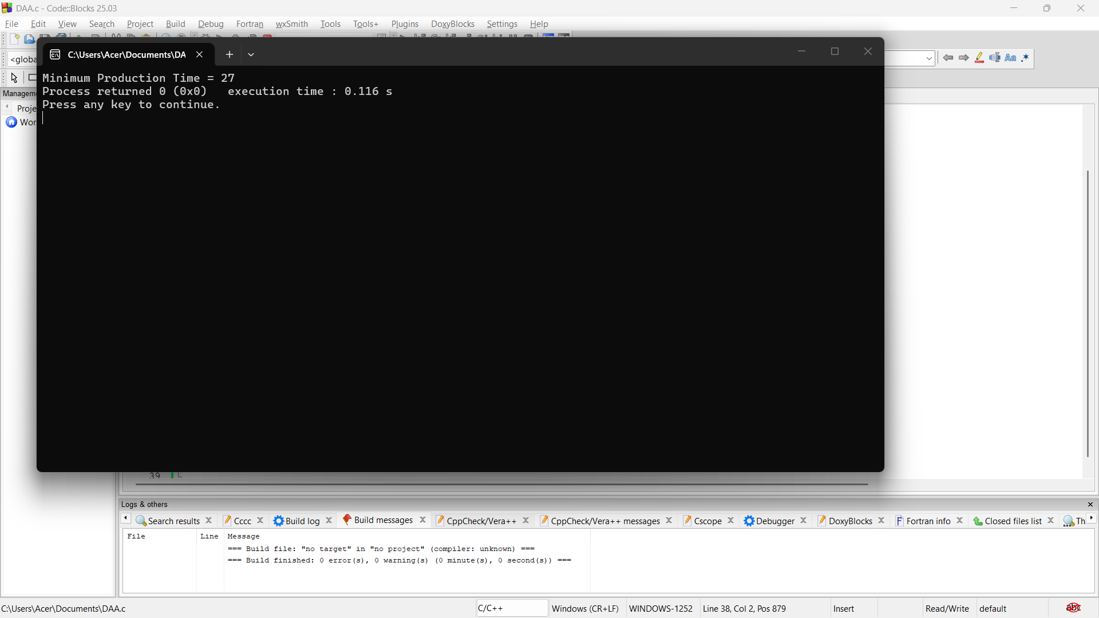

10. #include <stdio.h>

int main() {
int a1[] = {2, 4, 3};
int a2[] = {3, 2, 5};
int t1[] = {1, 2};
int t2[] = {2, 1};
int e1 = 6, e2 = 7;
int x1 = 5, x2 = 4;
int n = 3;

int f1[3], f2[3];

f1[0] = e1 + a1[0];
f2[0] = e2 + a2[0];

for (int i = 1; i < n; i++) {
if (f1[i - 1] + a1[i] < f2[i - 1] + t2[i - 1] + a1[i])
f1[i] = f1[i - 1] + a1[i];
else
f1[i] = f2[i - 1] + t2[i - 1] + a1[i];

if (f2[i - 1] + a2[i] < f1[i - 1] + t1[i - 1] + a2[i])
f2[i] = f2[i - 1] + a2[i];
else
f2[i] = f1[i - 1] + t1[i - 1] + a2[i];
}

int ans;
if (f1[n - 1] + x1 < f2[n - 1] + x2)
ans = f1[n - 1] + x1;
else
ans = f2[n - 1] + x2;

printf("Minimum Production Time = %d", ans);

return 0;
}

